Statement of Conformance 2024

The owners and directors of Guardforce Security who are responsible and accountable for all company activities globally, endorse this statement of conformance and their and their staff’s obligations and responsibilities to respect all human rights as reflections within the company Security Operations Management System which is inclusive of but not limited to:

- International Code of Conduct for Private Security Service Providers (ICoCA) https://icoca.ch/

- The Montreux Document on Pertinent International legal Obligations and Good Practices for States related to Operations of Private Military and Security Companies during Armed Conflict. https://www.montreuxdocument.org/

- Human Rights Act 1998 https://www.legislation.gov.uk/ukpga/1998/42/contents

- Guiding Principles of Business and Human Rights, Implementing the United Nations ‘Protect, Respect and Remedy’ framework 2011.
https://www.ohchr.org/sites/default/files/documents/publications/guidingprinciplesbusinesshr_en.pdf

- All other applicable international recognised Human Rights commitments.

Given the company’s commutments as listed, there is an expectation from the business owners that all staff and suppliers, stakeholders and interested parties commit to the same governing principles regarding Human Rights.

Guardforce Security Human Rights Policy Statement

The purpose of the Policy is to communicate to the Guardforce employees, staff, contractors, subcontractors, suppliers and community where the company operates, the ethical and social values the company respect and seek to uphold throughout its business decisions, activities, and partnerships.

The Policy outlines the commitment of Guardforce Security to respecting human rights and values of Integrity, Respect, Colleagueship and Ownership, as reflected in Guardforce documents and which are the unifying force for all departments. Upholding international recognised laws and frameworks and all relevant national laws where Guardforce operates.

Guardforce Security will at all times – from Director level down – ensure that all statutory legislation relating to Human Rights are adhered to through both the policies and processes that we write and the staff and managers who implement them.
What Are Human Rights?

Human rights are the basic rights and freedoms that belong to every person in the world. They are based on shared values like dignity, fairness, equality, respect, and independence. In many countries where we operate, these values are defined and protected by law. In some countries, however, this is not the case. Where national law and international human rights standards differ, Guardforce Security will follow the higher standard. Where they are in conflict Guardforce Security will adhere to national law, whilst seeking ways to respect international human rights to the greatest extent possible.

Commitments and Principles: Statement
In line with the United Nations Guiding Principles on Business and Human Rights Guardforce Security are committed to the United Nations Universal Declaration of Human Rights, the International Labour Organisation’s (ILO) core labour standards and the ILO’s Declaration on the Fundamental Principles and Rights at Work.

Guardforce Security commits to performing its business to the given standards of ethics in accordance with company values and the laws where the company operate.

- Be open and fair in dialogue with all our stakeholders and commit to communicating effectively with external parties, ensuring there is trusted and accessible consultation mechanisms available.
- Work to address key issues relevant to our sector, business activity and supply chains including: modern slavery and exploitative labour practices, child labour, all forms of discrimination, fair wages, working hours and conditions, health, and safety, right to freedom of association.
- Continue to develop company due diligence processes to provide more insight to help identify risks and ensure the company understands best approaches to preventing and mitigating risks to people.
- Not tolerate, nor condone abuse of human rights within any part of the business or supply chains, and will take any allegations of abuse seriously. As part of this the company will work to ensure effective provision of remedy wherever human rights occur through company-based grievance mechanisms.

Raising Concerns

If any stakeholders identify an issue with either company practice or that of a supplier or interested party, these concerns can be raised directly with the company ensuring all contact is confidential at all times. On the company website there is a Complaints Process which explains the pathway needed to be taken, if a staff member this can done under the Whistle Blower Pilocy which maintains the same complete confidentiality.

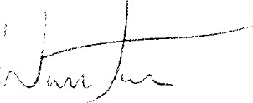
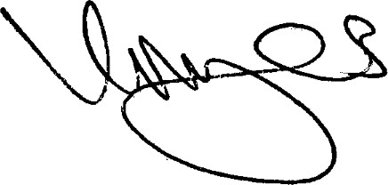
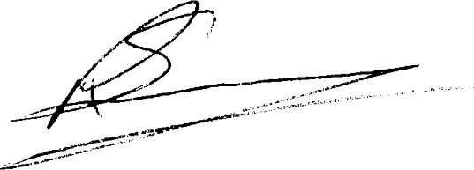
Warren Jones Russell Sampayo Kevin Myers

